**ACTIVATION OF MFA SECURITY**

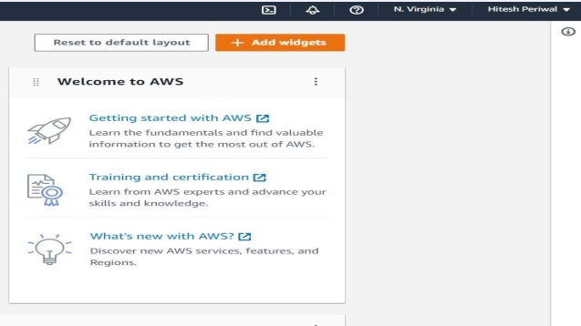

**Click on “Hitesh Periwal”**

**Visit** **aws.amazon.com** **and Sign in**

**1.….**.

**2.**

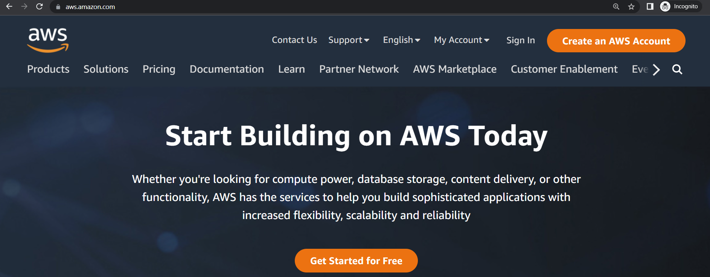

**Click on “Assign MFA device”**

**Click on “Security credentials”**

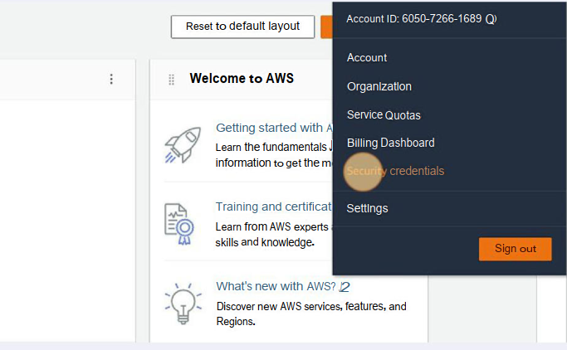

**s**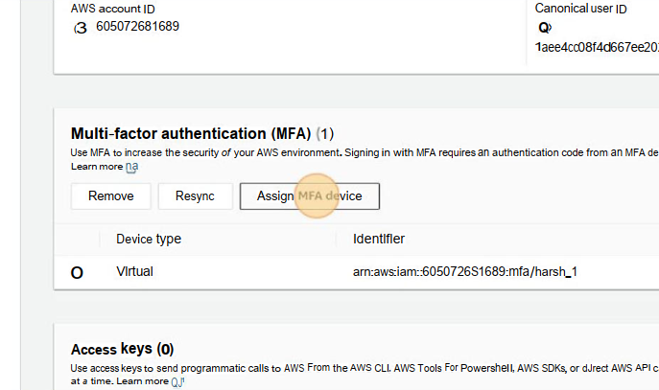

**3.**

**4.….**.

**Enter the Device name**

**Click on the "Authenticator app” option**

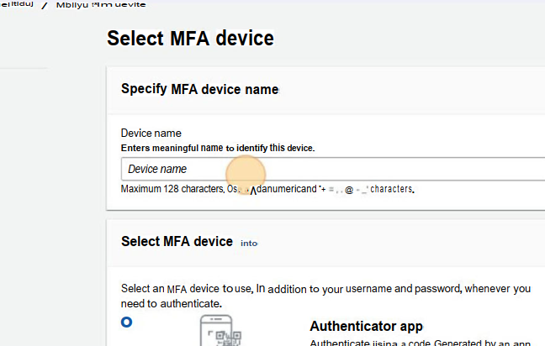

**5.….**.

**6.….**.

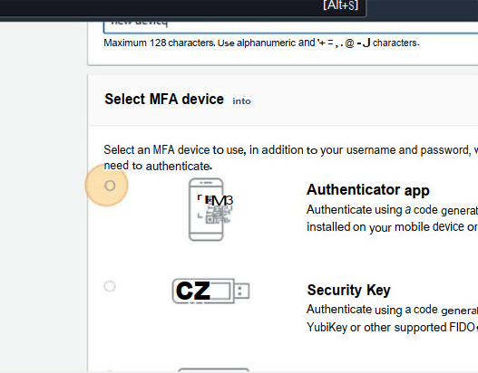

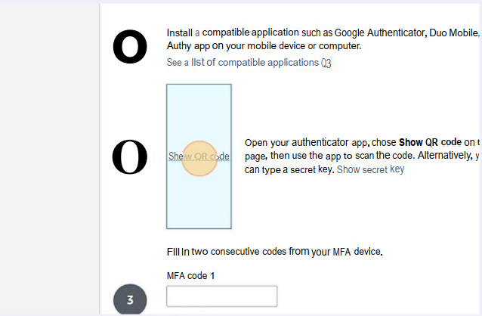

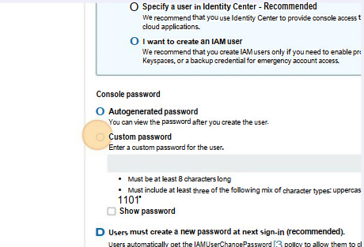

**Download Authenticator from Google Play Store on your Smart Phone.Then click on PLUS button.  
Then click on "Scan a QR Code".Then come back to Desktop Screen.Click "Show QR code”**

**Click on “Next”**

**8.….**.

**7.….**.

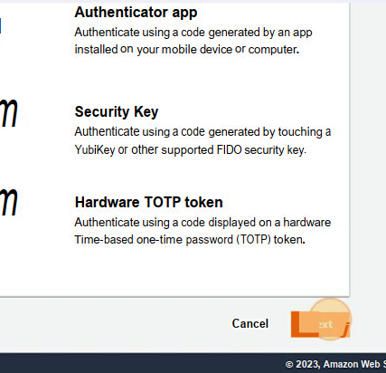

**Get two consecutive MFA code from smartphone and enter in the respective fields**

**Click on “Add MFA” and thus MFA has been added**

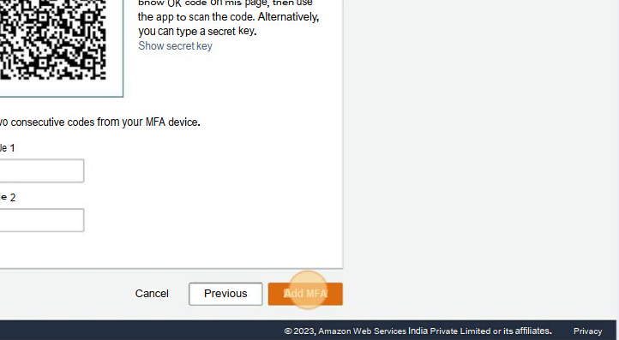

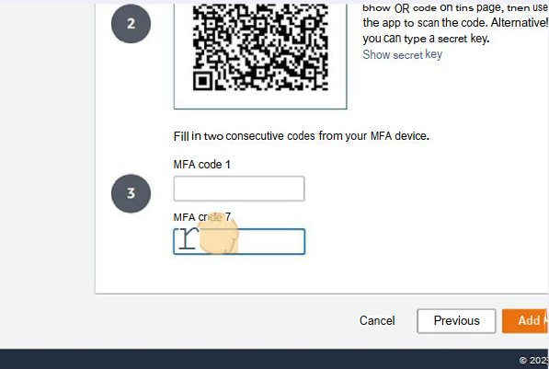

**10.….**.

**9.….**.